1.Tips healthy lungs

sometimes we take our lungs for granted. They keep us alive and well and for the most part, we don't need to think about them. That's why it is important to prioritize your lung health.

Your body has a natural defense system designed to protect the lungs, keeping dirt and germs at bay. But there are some important things you can do to reduce your risk of lung disease. Here are some ways to keep your lungs healthy.

**Don't Smoke**

Cigarette smoking is the major cause of [lung cancer](https://www.lung.org/lung-health-diseases/lung-disease-lookup/lung-cancer) and chronic obstructive pulmonary disease ([COPD](https://www.lung.org/lung-health-diseases/lung-disease-lookup/copd)), which includes chronic bronchitis and emphysema. Cigarette smoke can narrow the air passages and make breathing more difficult. It causes chronic inflammation, or swelling in the lung, which can lead to chronic bronchitis. Over time cigarette smoke destroys lung tissue and may trigger changes that grow into cancer. If you smoke, it's never too late to benefit from quitting. [The American Lung Association can help whenever you are ready.](https://www.lung.org/quit-smoking/i-want-to-quit)

**Avoid Exposure to Indoor Pollutants That Can Damage Your Lungs**

Secondhand smoke, chemicals in the home and workplace, and radon all can cause or worsen lung disease. Make your home and car smokefree. Test your home for [radon](https://www.lung.org/clean-air/at-home/indoor-air-pollutants/radon). Avoid exercising outdoors on bad air days. And talk to your healthcare provider if you are worried that something in your [home](https://www.lung.org/clean-air/at-home), [school](https://www.lung.org/clean-air/at-school)or [work](https://www.lung.org/clean-air/at-work)may be making you sick.

**Minimize Exposure to Outdoor Air Pollution**

The air quality outside can vary from day to day and sometimes is unhealthy to breathe. Knowing how [outdoor air pollution](https://www.lung.org/clean-air/outdoors) affects your health and useful strategies to minimize prolonged exposure can help keep you and your family well. [Climate change](https://www.lung.org/clean-air/climate-change) and [natural disasters](https://www.lung.org/clean-air/emergencies-and-natural-disasters) can also directly impact lung health.

**Prevent Infection**

A cold or other respiratory infection can sometimes become very serious. There are several things you can do to protect yourself:

* Wash your hands often with soap and water. Alcohol-based cleaners are a good substitute if you cannot wash.
* Avoids crowds during the cold and flu season.
* Good oral hygiene can protect you from the germs in your mouth leading to infections. Brush your teeth at least twice daily and see your dentist at least every six months.
* Get vaccinated every year against [influenza](https://www.lung.org/lung-health-diseases/lung-disease-lookup/influenza). Talk to your healthcare provider to find out if the [pneumonia](https://www.lung.org/lung-health-diseases/lung-disease-lookup/pneumonia)vaccine is right for you.
* If you get sick, keep it to yourself! Protect the people around you, including your loved ones, by keeping your distance. Stay home from work or school until you're feeling better.

**Get Regular Check-ups**

Regular check-ups help prevent diseases, even when you are feeling well. This is especially true for lung disease, which sometimes goes undetected until it is serious. During a check-up, your healthcare provider will listen to your breathing and listen to your concerns. If you need health insurance, [learn more about your options.](https://www.lung.org/policy-advocacy/healthcare-lung-disease/healthcare-policy/our-lungs-and-aca)

**Exercise**

Whether you are young or old, slender or large, able-bodied or living with a chronic illness or disability, being physically active can help keep your lungs healthy. [Learn more about how exercise can strengthen your lungs.](https://www.lung.org/lung-health-diseases/wellness/exercise-and-lung-health)

**Public Health and Your Lungs**

Health begins where we live, learn, work and play, and it's important to ensure that safeguards are in place to protect us and prevent disease.

[**SEE HOW PUBLIC HEALTH ISSUES CAN AFFECT LUNG HEALTH.**](https://www.lung.org/lung-health-diseases/wellness/public-health-issues-lung-health)

Page last updated: May 7, 2021

A nagging cough or slight wheeze may barely register in the course of our busy days, but it's critically important to pay attention to even mild symptoms. Sometimes people think having trouble breathing is just something that comes with [getting older](https://www.lung.org/lung-health-diseases/how-lungs-work/lung-capacity-and-aging). It is important to pay attention to these symptoms as they could be the first signs of lung disease, including COPD, asthma and lung cancer. Knowing the early warning signs of lung disease can help you receive treatment before the disease becomes serious or even life threatening. If you experience any of the following warning signs, make an appointment with your healthcare provider as soon as possible. Early detection could save your life.

# 2.Warning Signs of Lung Disease

## Warning Signs

**Chronic cough:** A [cough](https://www.lung.org/lung-health-diseases/lung-disease-lookup/cough) that you have had for eight weeks or longer is considered chronic. This is an important early symptom that tells you something is wrong with your respiratory system.

**Shortness of breath:**It's not normal to experience [shortness of breath](https://www.lung.org/lung-health-diseases/lung-disease-lookup/shortness-of-breath) that doesn't go away after exercising, or that you have after little or no exertion. Labored or difficult breathing—the feeling that it is hard to breathe in out—is also a warning sign.

**Chronic mucus production:** Mucus, also called sputum or phlegm, is produced by the airways as a defense against infections or irritants. If your mucus production has lasted a month or longer, this could indicate lung disease.

**Wheezing:**Noisy breathing or wheezing is a sign that something unusual is blocking your lungs' airways or making them too narrow.

**Coughing up blood:** If you are coughing up blood, it may be coming from your lungs or upper respiratory tract. Wherever it's coming from, it signals a health problem.

**Chronic chest pain:**Unexplained chest pain that lasts for a month or more—especially if it gets worse when you breathe in or cough—also is a warning sign.

### Talking to Your Doctor

Prepare for a visit to your healthcare provider by following these steps:

1. Take a copy of your medical records with you. Or, see if your previous healthcare provider can send a copy. If you are unable to obtain your medical records, you can also write a short note about your health problems, when they occurred and the healthcare provider(s) that took care of you.
2. Make a list of all the medicines that you are using now. This means prescribed and over-the-counter medicines, as well as herbs and supplements and any non-traditional methods you use to treat your condition.
3. Make a list of all the healthcare providers you see and why you see them.
4. Make a list of the symptoms you are having and note which ones bother you the most. Write down when they started and what you have done (if anything) to make them better.

## Questions about Lung Health?

Call our Lung HelpLine. Get free counseling with our registered nurses, respiratory therapists and quit smoking specialists; 1-800-LUNGUSA (586-4872).

[**CONTACT US**](https://www.lung.org/support-community/lung-helpline-and-tobacco-quitline)

Page last updated: July 29, 2020

# 7 home remedies for shortness of breath

* [Home remedies](https://www.medicalnewstoday.com/articles/319175#home-remedies)
* [Reducing triggers](https://www.medicalnewstoday.com/articles/319175#reducing-triggers)
* [Causes](https://www.medicalnewstoday.com/articles/319175#causes)
* [Symptoms](https://www.medicalnewstoday.com/articles/319175#symptoms)
* [Seeing a doctor](https://www.medicalnewstoday.com/articles/319175#seeing-a-doctor)
* [Summary](https://www.medicalnewstoday.com/articles/319175#summary)

Shortness of breath, or breathlessness, occurs when a person has difficulty taking in enough air to breathe. It can range from mild to severe.

The medical term for shortness of breath is [dyspnea](https://www.medicalnewstoday.com/articles/314963). Despite being relatively common, it can be uncomfortable and distressing to experience.

That being said, when it is not a symptom of a more serious condition, it is usually possible to manage it at home.

This article will explore some remedies for shortness of breath that people can try at home. It will also look at the symptoms and causes of breathlessness and when to see a doctor.

## Home remedies

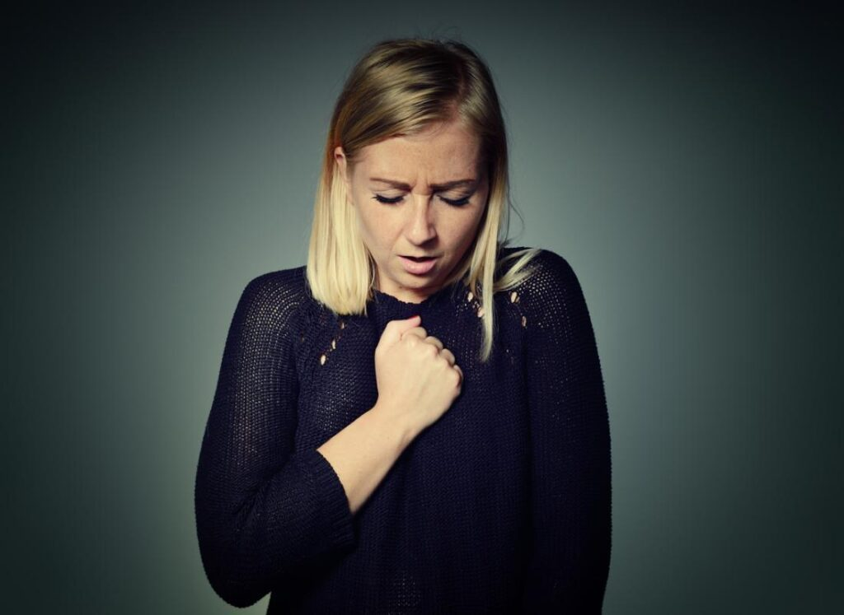Share on Pinterest

When a person knows what is causing their shortness of breath and it is not a medical emergency, they may want to try easing it at home.

The following exercises can help ease breathlessness at home:

### 1. Deep breathing

Breathing in deeply through the abdomen can help someone manage their breathlessness. To try deep breathing at home, people can:

1. Lie down and place the hands on the abdomen.
2. Breathe in deeply through the nose, expanding the abdomen and letting the lungs fill with air.
3. Hold the breath for a couple of seconds.
4. Breathe out slowly through the mouth, emptying the lungs.

People can do this exercise several times per day or as often as they experience shortness of breath. It is best to keep breathing slowly, easily, and deeply rather than quickly.

People can also try other types of deep breathing exercise, such as [diaphragmatic breathing](https://www.medicalnewstoday.com/articles/diaphragmatic-breathing).

That said, the quality of evidence behind deep breathing exercises for shortness of breath [is limited](https://bmcpulmmed.biomedcentral.com/articles/10.1186/1471-2466-14-184), and research is ongoing.

But,here are also some risks associated with performing deep breathing exercises incorrectly. Indeed, [research](https://openres.ersjournals.com/content/3/4/00065-2017) suggests that when a person performs them incorrectly, these exercises can be more harmful than helpful.

For example, in some people with severe chronic respiratory conditions, deep breathing exercises can lead to hyperinflation, which occurs when an increase in lung volume prevents efficient airflow in the body.

Other risks include reduced strength of the diaphragm and increased shortness of breath.

If possible, perform these exercises with the help of a trained medical professional to reduce potential risks.

### 2. Pursed lip breathing

Another breathing exercise that can help relieve shortness of breath is [pursed lip breathing](https://www.medicalnewstoday.com/articles/325555).

Pursed lip breathing helps reduce breathlessness by slowing the pace of a person’s breathing. This is particularly useful if shortness of breath is due to [anxiety](https://www.medicalnewstoday.com/info/anxiety/).

To try pursed lip breathing at home, people can:

1. Sit upright in a chair with the shoulders relaxed.
2. Press the lips together, keeping a small gap between them.
3. Inhale through the nose for a couple of seconds.
4. Gently exhale through the pursed lips for a count of four.
5. Repeat this breathing pattern a few times.

People can try this exercise whenever they feel short of breath, and they can repeat it throughout the day until they feel better.

It is important to note that the quality and strength of the research into pursed lip breathing is very limited. [Research](https://bmcpulmmed.biomedcentral.com/articles/10.1186/1471-2466-14-184) into its effectiveness is ongoing.

### 3. Finding a comfortable and supported position

Finding a comfortable and supported position to stand or lie in can help someone relax and catch their breath. If shortness of breath is due to anxiety or overexertion, this remedy is particularly helpful.

The following positions can relieve pressure on a person’s airways and improve their breathing:

* sitting forward in a chair, preferably using a table to support the head
* leaning against a wall so that the back is supported
* standing with the hands supported on a table, to take the weight off the feet
* lying down with the head and knees supported by pillows

### 4. Using a fan

A [study from 2010](http://www.jpsmjournal.com/article/S0885-3924(10)00160-0/fulltext) reports that using a handheld fan to blow air across the nose and face could reduce the sensation of breathlessness.

Feeling the force of air while inhaling can make it feel as though more air is entering the body. Therefore, this remedy may be effective in reducing the sensation of breathlessness.

The use of a fan may not improve symptoms that occur due to an underlying medical condition, however.

In another [study](https://bmcpalliatcare.biomedcentral.com/articles/10.1186/1472-684X-9-22), the researchers did not find any clear benefit from using fan therapy, though it did appear to help some groups.

More work is necessary to determine who might benefit from this remedy.

### 5. Inhaling steam

Inhaling steam can help keep a person’s nasal passages clear, which can help them breathe more easily. Heat and moisture from steam may also break down mucus in the lungs, which might also reduce breathlessness.

To try steam inhalation at home, a person can:

1. Fill a bowl with very hot water.
2. Add a few drops of peppermint or eucalyptus essential oil.
3. Position the face over the bowl, and place a towel over the head.
4. Take deep breaths, inhaling the steam.

People should leave the water to cool slightly if it has just boiled. Otherwise, the steam could scald the skin on the face.

### 6. Drinking black coffee

Drinking black [coffee](https://www.medicalnewstoday.com/articles/270202.php) may help ease breathlessness, as the caffeine in it can reduce tightness in the muscles in a person’s airway.

A [review from 2010Trusted Source](http://onlinelibrary.wiley.com/doi/10.1002/14651858.CD001112.pub2/full) reported that caffeine’s effects slightly improve the way the airway functions in people with [asthma](https://www.medicalnewstoday.com/info/asthma/). This can be enough to make it easier for them to take in air.

However, it is important to remember that drinking too much coffee can increase a person’s heart rate. People should watch their caffeine intake when trying this remedy to make sure that they do not drink too much.

### 7. Eating fresh ginger

Eating fresh [ginger](https://www.medicalnewstoday.com/articles/265990.php), or adding some to hot water as a drink, may help reduce shortness of breath that occurs due to a respiratory infection.

[One studyTrusted Source](https://www.ncbi.nlm.nih.gov/pubmed/23123794) suggests that ginger may be effective in fighting the [respiratory syncytial virus](https://www.medicalnewstoday.com/articles/301632.php), which is a common cause of respiratory infections.

## Identifying and reducing triggers

Depending on the cause of the breathlessness, there may be some changes that a person can make to their lifestyle to avoid their triggers and ease their symptoms.

These changes include:

* losing weight, if [obesity](https://www.medicalnewstoday.com/info/obesity/how-much-should-i-weigh.php) is the cause of the breathing problems
* exercising, to improve fitness levels
* avoiding exercise in hot conditions or at high altitudes
* [quitting smoking](https://www.medicalnewstoday.com/articles/241302.php) or avoiding secondhand smoke
* avoiding allergens and pollutants
* sticking to treatment plans for any underlying conditions